**IOT & Cyber Security**

~Week 2~

1. **How many hops from your machine to your assigned website?**

In order to count number and order of hops, we have to execute **tracert [website address]** command.

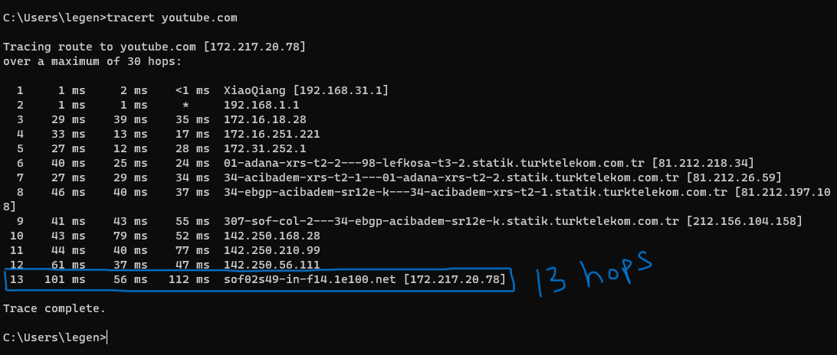

1. **Which step causes the biggest delay in the route? What is the average duration of that delay?**

Since 2nd line has 1 timeout it has the biggest delay in the route. The average duration is 106ms.

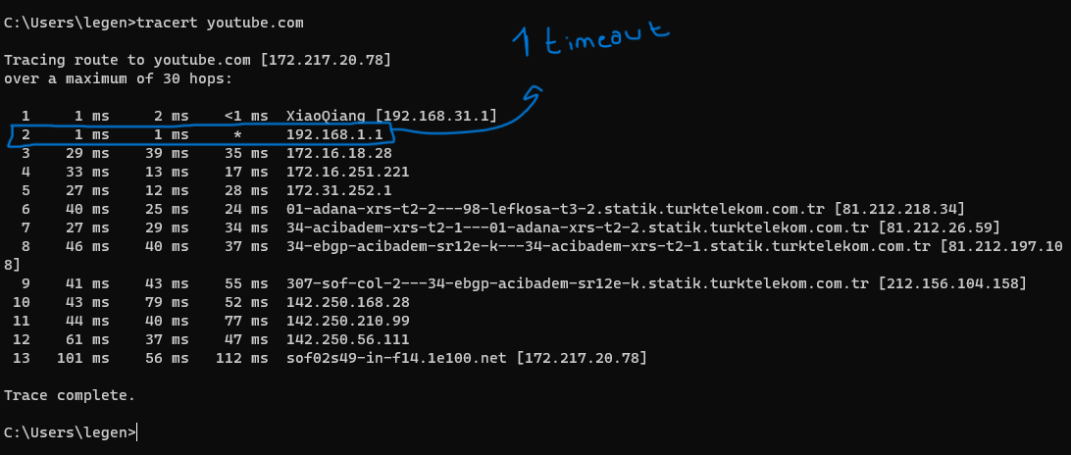

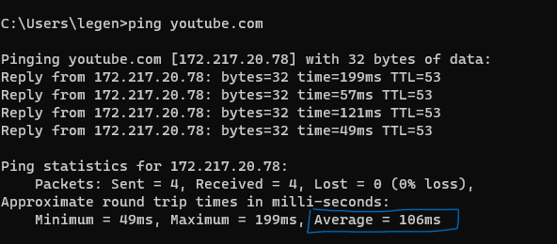

1. **What are the main nameservers for the website?**

The main nameserver is **youtube.com**

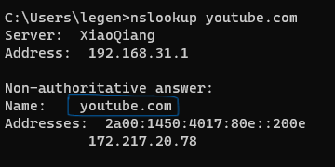

1. **Who is the registered contact?**

We have to execute **whois** **[website address]** command to check details of registred contact. Since I have been using Ubuntu for almost 1 year, I executed this command via Linux replica for windows.

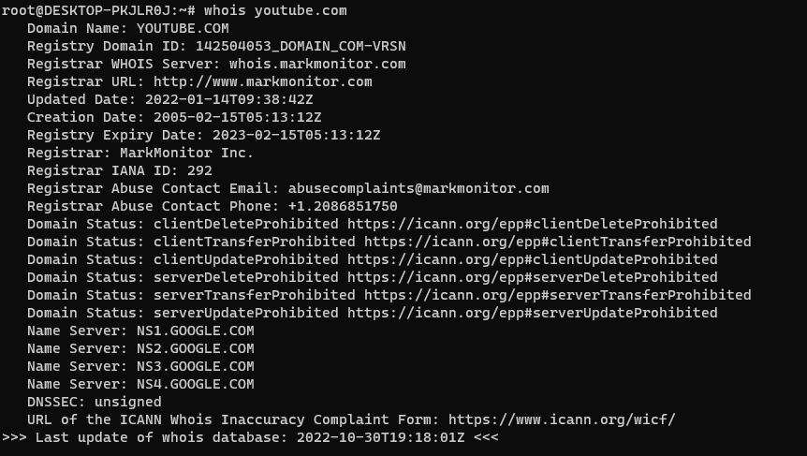

1. **What is the MX Record for the website?**

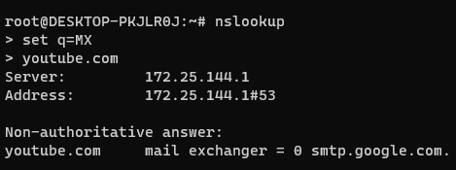

1. **Where is the website hosted?**

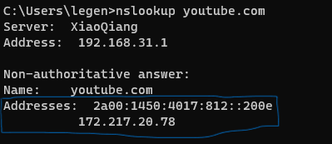

**Reflection Section**

**Did you have any issues or challenges with the scans?**

I confused on question 5. I struggled to find valid answer for it.

**How did you overcome them ?**

I decided to look it up on google and I figure it out by checking some documentation on cloudflare.com. There were some commands that I need to use which are the following

-nslookup

-set q=MX (This sets a filter to only collect MX records and related information)

-youtube.com (website name)

I entered this command and finally I got the SMTP (Email address) and more about MX record details.

**How will they affect your final report ?**

This exercise was quite informative and enjoyable for me. I love to work with CMD commands as a programmer. It is lifesaver most of the time. Our exercise’s aim for checking network details in general. In first question we checked our hops path from ISP to target website and observed the biggest delay in the route. In rest of the questions we used nslook up commands to check server names , addresses and MX records for our target website.